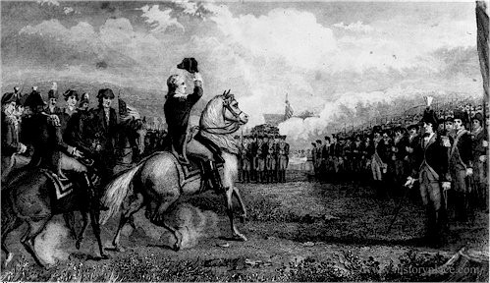
What Happened when the Continental Army
invaded Quebec in 1775?

In 1775, the rebels in the Thirteen Colonies launched an attack on the British colonies to the north. They though that if these colonies could be captured, then the whole continent would be united against the British.
General Washington sent an army of 4000 men to invade Quebec. He planned two attack routes. Part of the army, led by Major General Richard Montgomery, moved north from Fort Ticonderoga to Montreal. The other part, led by Benedict Arnold, trekked overland through the difficult Maine wilderness to Quebec City.
If Quebec could be captured, the British would not be able to launch an invasion from the St. Lawrence. Washington felt that he could win. He knew that Quebec had fewer than 1000 British troops. He also thought that the French population would rise against the British once the Continental Army appeared.
Montgomery captured Montreal and nearly captured the English General Guy Carleton. But Carleton disguised himself as a French trapper and escaped. Montgomery followed Carleton to Quebec.
Arnold’s part of the American army suffered terribly trying to get through the bogs, rapids and rocky terrain of the forest between the Atlantic and Quebec. The troops ran out of food and had to eat candles and roasted moccasins. Only 600 of the 1200 men who had set out reached Quebec. By the time the two armies joined up, winter had arrived. Conditions got worse and smallpox raged the camp.
Finally, Montgomery decided to attack while they still had some strength left. On New Year’s Eve 1775, he and Arnold launched a desperate night attack on the walls of Quebec. The sick and poorly dressed soldiers ploughed their way through metre-high snowdrifts in a driving storm. Snow got into their weapons and made them useless. And, to make matters worse, a spy had warned the British garrison of the attack. Carleton’s artillery opened fire at pointblank range. Two hundred of the American army were killed, including Montgomery, and Arnold was wounded. The British lost only six men. For the rest of the winter, the Continental Army lived in their disease-ridden camp. In May, British reinforcements under General Burgoyne arrived at Quebec and Arnold retreated to Fort Ticonderoga. The attack on Quebec failed.

1. How was the unsuccessful attack on Quebec important to the story of Canada?
2. If Washington and the colonial armies had won, Quebec and the other colonies would have become part of the Thirteen Colonies. Canada today might therefore have been very different. How do you think the defeat of Quebec would have changed Canada’s history? Would your own life be different?

- How was the unsuccessful attack on Quebec important to the story of Canada? The fact that the Americans had been resisted showed that the northern colonies did not agree with the Thirteen Colonies. They were not interested in joining with the Thirteen Colonies and preferred to remain as they were. The American dream of one country united against the Britain was not to come true.
- If Washington and the colonial armies had won, Quebec and the other colonies would have become part of the Thirteen Colonies. Canada today might therefore have been very different. How do you think the defeat of Quebec would have changed Canada’s history? Would your own life be different?
Personal Opinions

