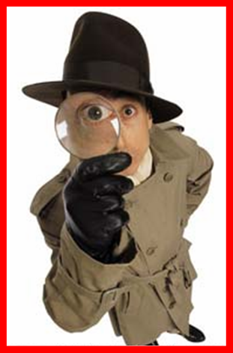**Collage –assignment (mini -assignment) Due Tuesday , September, 13 Total : 4 points**

Studying history is like putting together pieces of an old jigsaw. Some of the pieces are missing, and it is sometimes hard to fit the other pieces together.

▪ This is because historians have to work with evidence – photos, objects, letters and so on – that do not always give the full story.

▪ The job of the historian is to put the pieces together, and to fill the gaps in the picture.

Swap your collages with a partner in the class (choose someone you do not know very well!)

▪1. Look carefully at the evidence and use it to complete these questions:

2. Use the evidence to help you complete this table.

Describe the evidence here What does this evidence tell you about the person you are investigating?

1. a.

b.

c.

2. a.

b.

c.

3. a.

b.

c.

After having investigated the person, write up a paragraph about the individual that you have investigating ARGUING what kind of personality the given person possesses using the evidence gathered about this particular individual.

**Quality of the argument 2**

**Quality of the evidence 2**