20 Latin Phrases You Should Be Using
BY PAUL ANTHONY JONES AUGUST 26, 2016


ISTOCK

You’d probably be surprised by how much Latin you actually already know. Hundreds of words—like memo, alibi, agenda, census, veto, alias, via, alumni, affidavit and versus—are all used in everyday English, as are abbreviations like i.e. (id est, "that is") and etc. (et cetera, "and the rest"). Even some entire Latin phrases have become so naturalized in English that we use them, in full, without a second thought—like bona fide (literally "in good faith"), alter ego ("other self"), persona non grata ("unwelcome person"), vice versa ("position turned"), carpe diem ("seize the day"), cum laude ("with praise"), alma mater ("nourishing mother"), and quid pro quo ("something for something," "this for that").
Besides fairly commonplace examples like these, however, English has adopted a number of much less familiar Latin phrases and expressions that go criminally underused—20 examples of which are listed here. So next time you spot a misbehaving child, or you want to seize the night rather than the day, you’ll have the perfect phrase at hand.
Play
Unmute

0:40
/
0:48
Loaded: 0%

0:40
Progress: 0%

Share
Captions
Fullscreen
Astounding Terrarium Cakes

1. AURIBUS TENEO LUPUM
It might seem odd to say that you’re "holding a wolf by the ears," but auribus teneo lupum—a line taken from Phormio (c.161BC), a work by the Roman playwright Terence—was once a popular proverb in Ancient Rome. Like "holding a tiger by the tail," it is used to describe an unsustainable situation, and in particular one in which both doing nothing and doing something to resolve it are equally risky.
2. BARBA TENUS SAPIENTES


A man described as barba tenus sapientes is literally said to be "wise as far as his beard"—or, in other words, he might look intelligent but he’s actually far from it. This is just one of a number of phrases that show how the Romans associated beards with intelligence, alongside barba non facit philosophum, "a beard does not make a philosopher," and barba crescit caput nescit, meaning "the beard grows, but the head doesn’t grow wiser."
3. BRUTUM FULMEN
Apparently coined by the Roman scholar Pliny the Elder, a brutum fulmen is a harmless or empty threat. It literally means "senseless thunderbolt."
4. CAESAR NON SUPRA GRAMMATICOS


In a speech to the Council of Constance in 1414, the Holy Roman Emperor Sigismund of Luxembourg happened to use the Latin word schisma, meaning "schism." Unfortunately for him, he muddled up its gender—schisma should be a neuter word, but he used it as if it were feminine. When the error was pointed out to him, Sigismund angrily proclaimed that because he was Emperor, even if the word was neuter (which it was) it would be feminine from now on, at which point one member of the Council supposedly stood and replied, "Caesar non supra grammaticos"—or "the Emperor is not above the grammarians." The phrase quickly became a popular proverbial defence of the importance of good grammar and spelling.
5. CARPE NOCTEM


Carpe noctem is essentially the nocturnal equivalent of carpe diem and so literally means "seize the night." It too is used to encourage someone to make the most of their time, often in the sense of working into the early hours of the morning to get something finished, or else enjoying themselves in the evening once a hard day’s work is done.
6. CARTHAGO DELENDA EST

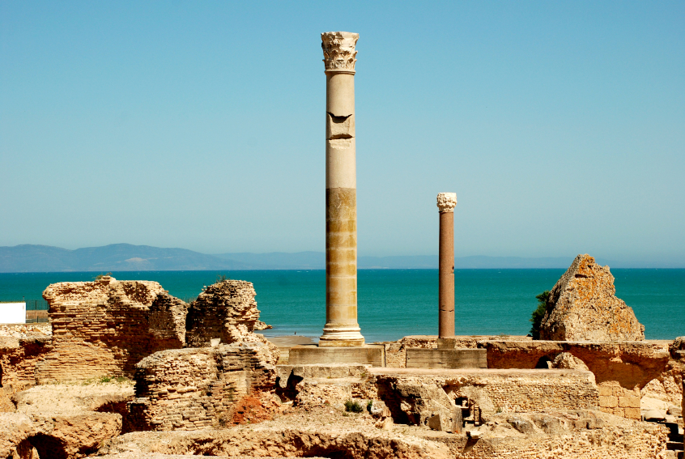
At the height of the Punic Wars, fought between Rome and Carthage from 264-146BC, a Roman statesman named Cato the Elder had a habit of ending all of his speeches to the Senate with the motto "Carthago delenda est," or "Carthage must be destroyed." His words quickly became a popular and rousing motto in Ancient Rome, and nowadays can be used figuratively to express your absolute support for an idea or course of action.
7. CASTIGAT RIDENDO MORES


Literally meaning "laughing corrects morals," the Latin motto castigat ridendo mores was coined by the French poet Jean de Santeul (1630-97), who intended it to show how useful satirical writing is in affecting social change: the best way to change the rules is by pointing out how absurd they are.
8. CORVUS OCULUM CORVI NON ERUIT

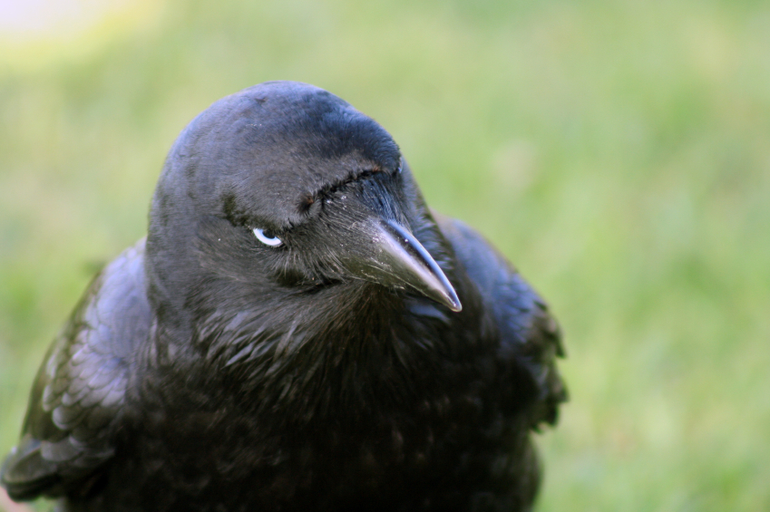
Picture a politician sticking up for a colleague even in the face of widespread criticism—that’s a fine example of the old Latin saying corvus oculum corvi non eruit, meaning "a crow will not pull out the eye of another crow." It’s essentially the same as "honor amongst thieves," and refers to complete solidarity amongst a group of likeminded people regardless of the consequences or condemnation.
9. CUI BONO?


Literally meaning "who benefits?," cui bono? is a rhetorical Latin legal phrase used to imply that whoever appears to have the most to gain from a crime is probably the culprit. More generally, it’s used in English to question the meaningfulness or advantages of carrying something out.
10. ET IN ARCADIA EGO
Arcadia was a rural region of Ancient Greece, whose inhabitants—chiefly shepherds and farmers—were seen as living a quiet, idyllic life away from the hustle and bustle of nearby Athens. The Latin motto et in Arcadia ego, "even in Arcadia, here I am," comes from the title of a painting by the French Baroque artist Nicholas Poussin (1594-1665) that depicted four Arcadian shepherds attending the tomb of a local man. Although precisely what Poussin meant the title to imply is hotly debated, but it’s often interpreted as a reminder that no matter how good someone else’s life appears to be compared to your own, we all eventually suffer the same fate—the "I" in question is Death.
11. EX NIHILO NIHIL FIT


Supposedly a quote by the Roman philosopher Lucretius, the Latin motto ex nihilo nihil fit means "nothing comes from nothing," and is used as a reminder that hard work is always required in order to achieve something.
12. FELIX CULPA


Originally a religious term referring to consequences of the Biblical Fall of Man and the sins of Adam and Eve, a felix culpa is literally a "happy fault"—an apparent mistake or disaster that actually ends up having surprisingly beneficial consequences.
13. HANNIBAL AD PORTAS


Wikimedia Commons // Public Domain
Hannibal was a Carthaginian military commander during the Punic Wars who, in the early 2nd century BC, led numerous devastating attacks against the Roman Empire. To the people of Rome, the threat of an attack from Hannibal soon made him something of a bogeyman, and as a result Roman parents would often tell their unruly children that Hanniabl ad portas—"Hannibal is at the gates"—in order to scare them into behaving properly.
14. HIC MANEBIMUS OPTIME
When the Gauls invaded Rome in 390BC, the Senate met to discuss whether or not to abandon the city and flee to the relative safety of nearby Veii. According to the Roman historian Livy, a centurion named Marcus Furius Camillus stood to address the Senate and exclaimed, "hic manebimus optime!"—or "here we will stay, most excellently!" His words soon came to be used figuratively of anyone’s unfaltering and dedicated intention to remain in place despite adverse circumstances.
15. HOMO SUM HUMANI A ME NIHIL ALIENUM PUTO


Homo sum humani a me nihil alienum puto is another line lifted from one of the works of the Roman dramatist Terence, in this case his play Heauton Timorumenos, or The Self-Tormentor. Originally in the play the line was merely one character’s response to being told to mind his own business, but given its literal meaning—"I am a human being, so nothing human is strange to me"—it has since come to be used as a motto advocating respect for people and cultures that appear different from your own.
16. IGNOTUM PER IGNOTIUS


Also known as obscurum per obscurius ("the obscure by the more obscure"), the phrase ignotum per ignotius ("the unknown by the more unknown") refers to an unhelpful explanation that is just as (or even more) confusing than that which it is attempting to explain—for instance, imagine someone asking you what obscurum per obscurius meant, and you telling them that it means the same as ignotum per ignotius.
17. IMPERIUM IN IMPERIO
Meaning "an empire within an empire," the Latin phrase imperium in imperio can be used literally to refer to a self-governing state confined within a larger one; or to a rebellious state fighting for independence from another; or, more figuratively, to a department or a group of workers in an organization who, despite appearing to work for themselves, are still answerable to an even larger corporation.
18. PANEM ET CIRCENSES


Panem et circenses, meaning "bread and circuses," refers to the basic needs and desires—i.e., food and entertainment—required to keep a person happy. It is taken from the Satires, a collection of satirical poems by the Roman poet Juvenal written in the 1st-2nd century AD.
19. VELOCIUS QUAM ASPARAGI COQUANTUR


According to the Romans, when something happens quickly it happens velocius quam asparagi conquantur —or "faster than you can cook asparagus." Some sources attribute this phrase to the Roman Emperor Augustus, but there’s sadly little proof that that’s the case.
20. VOX NIHILI


While vox populi is "the voice of the people," vox nihili is literally "the voice of nothing." It describes an utterly pointless or meaningless statement, but can also be used for the kind of spelling mistake or textual error in which one word is mistakenly substituted for another—like an Autocorrect mistake.
All images courtesy of iStock unless otherwise noted

