IB DP History Move to Global War: Japanese Expansion Name:

Directions: For each document answer the question, and then give the value and limitations of the origin, purpose and content for a historian studying this time period.
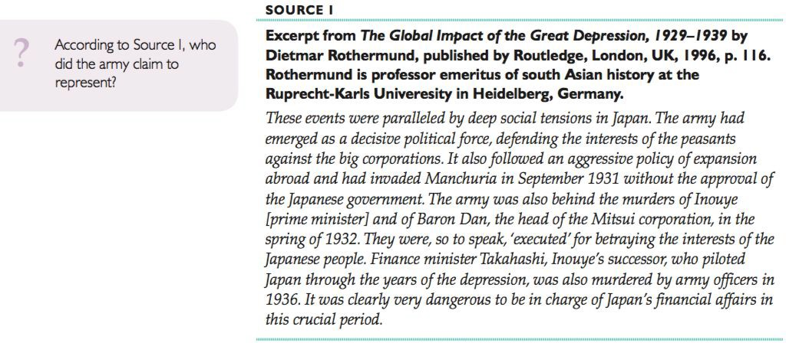

Answer the above question here:

 | Value | Limitations
Origin
Purpose
Content

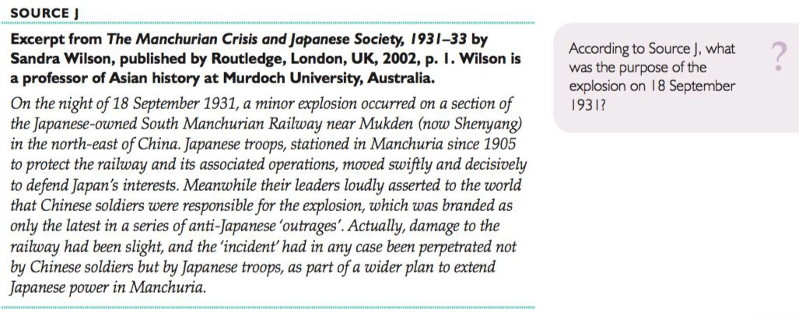

Answer the above question here:

 | Value | Limitations
Origin
Purpose
Content

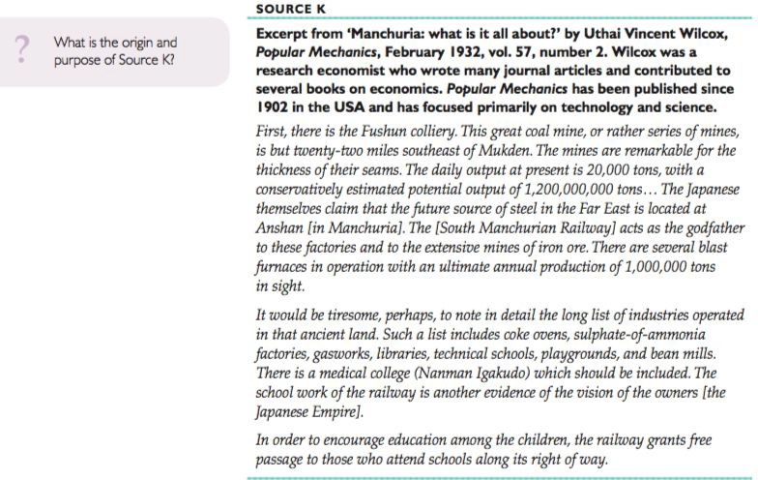

Answer the above question here:

 | Value | Limitations
Origin
Purpose
Content

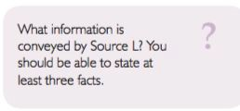
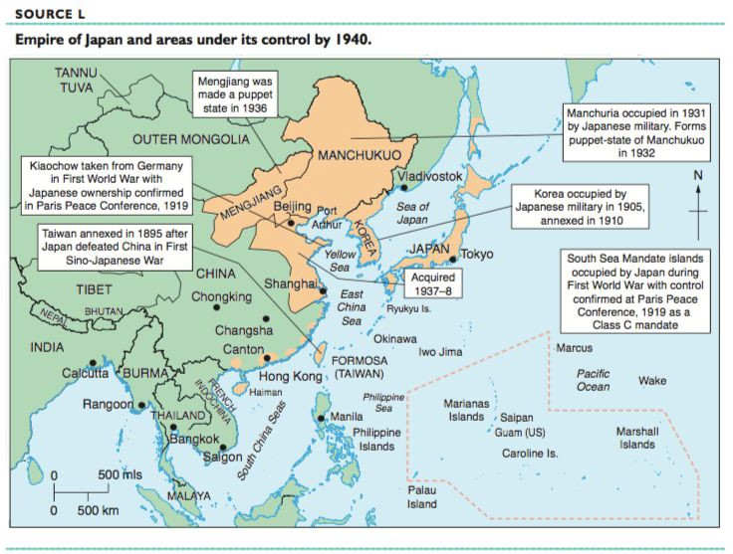

Answer the above question here:

 | Value | Limitations
Origin
Purpose
Content

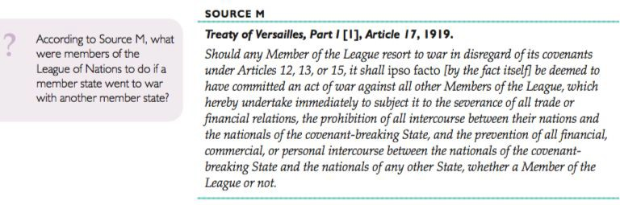

Answer the above question here:

 | Value | Limitations
Origin
Purpose
Content

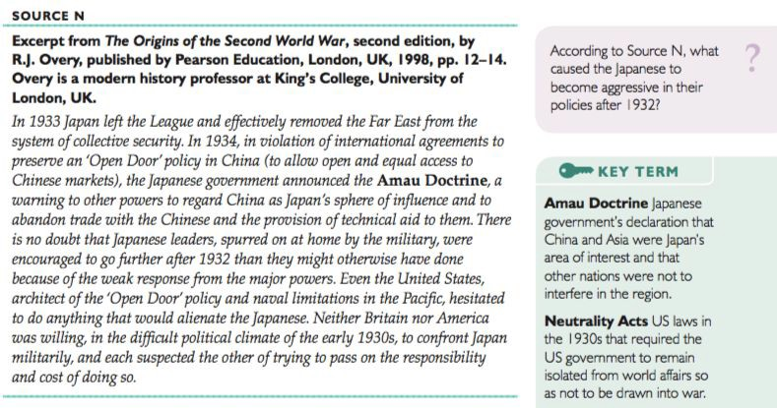

Answer the above question here:

 | Value | Limitations
Origin
Purpose
Content

